## Players and Monsters

NOTE: You need a public class **Main**. Create a package hero.

Your task is to create the following game hierarchy:

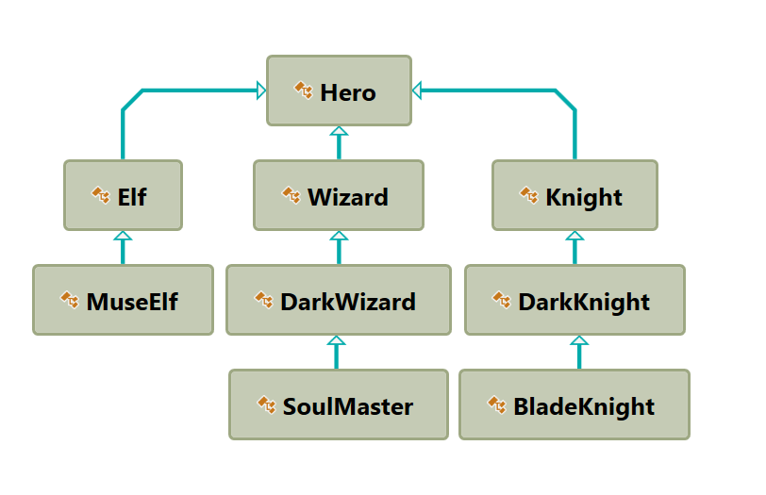

Create a class Hero. It should contain the following members:

* A public constructor, which accepts:
  + **username – String**
  + **level – int**
* The following fields:
  + **username - String**
  + **level – int**
* Getters for username and level
* **toString()** method